OP: Null pointer exception (Hello world will not be printed)

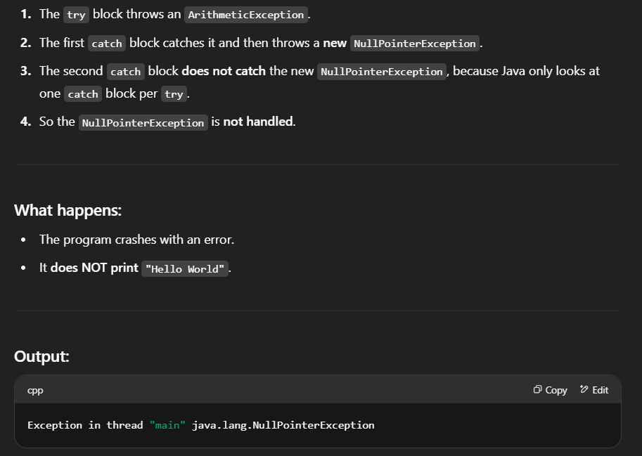

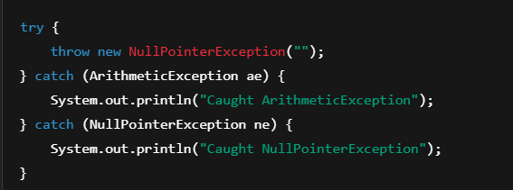

OP: Caught NullPointerException

Why multiple catch with one try? Coz, only one try block will run with whom the exception will matches.

Error as ArrayIndexOutOfBound is not reachable

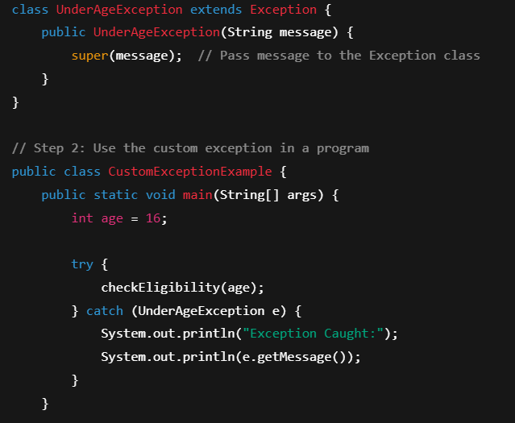

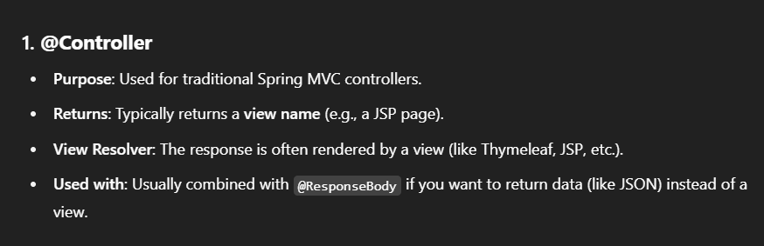

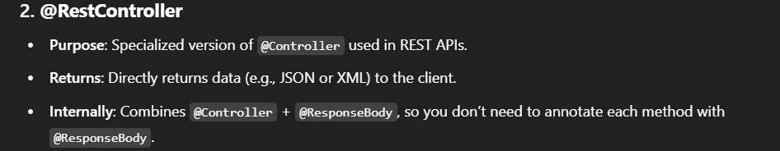

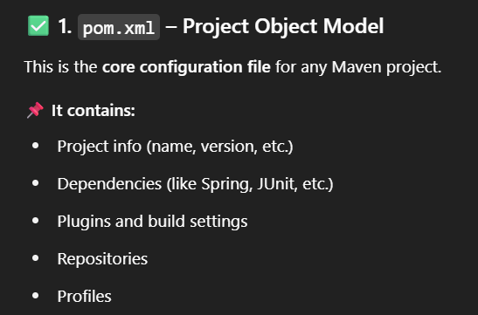

Try with Resources

It's a special kind of try block that **automatically closes resources** like files, streams, or anything that implements AutoCloseable.

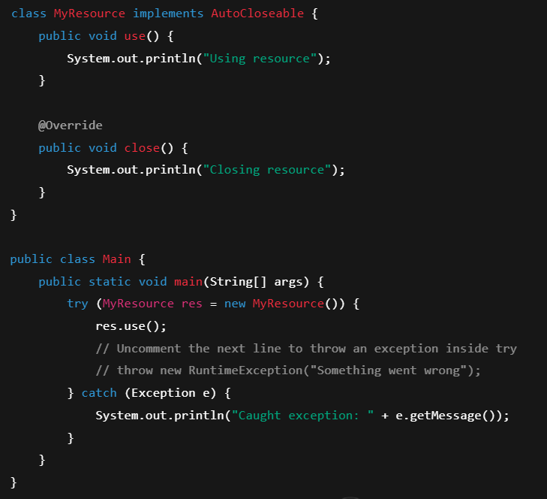

How to make a class read only



